1 Create the 5 partition as par below

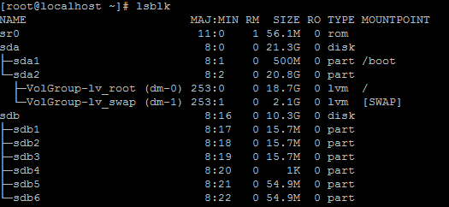

Update the partition table as with partprobe command

2. format the partition in ext4

[root@localhost ~]# mkfs.ext4 /dev/sdb1

[root@localhost ~]# mkfs.ext4 /dev/sdb2

[root@localhost ~]# mkfs.ext4 /dev/sdb3

[root@localhost ~]# mkfs.ext4 /dev/sdb4

[root@localhost ~]# mkfs.ext4 /dev/sdb5

Mount the partition

[root@localhost ~]# mount /dev/sdb1 /mount1

[root@localhost ~]# mount /dev/sdb2 /mount2

[root@localhost ~]# mount /dev/sdb3 /mount3

[root@localhost ~]# mount /dev/sdb4 /mount4

[root@localhost ~]# mount /dev/sdb5 /mount5

And also trying to permanently mount one partition in vim /etc/fstab

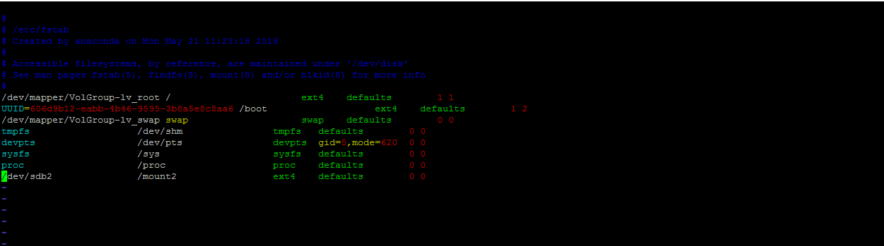

Unmount the Partition from the /etc/fstab

After the run the

[root@localhost ~]# mount -a

But Still partition showing in partition table like that

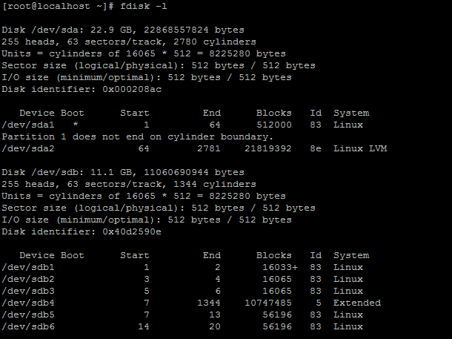

Now we are going to delete the partition

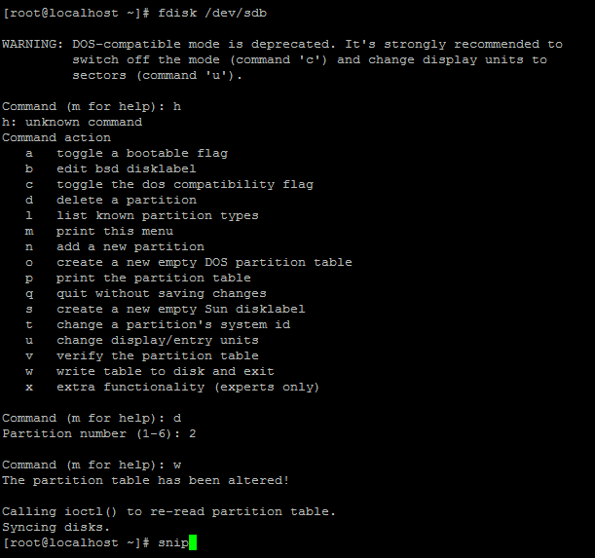

Deleted all the partition

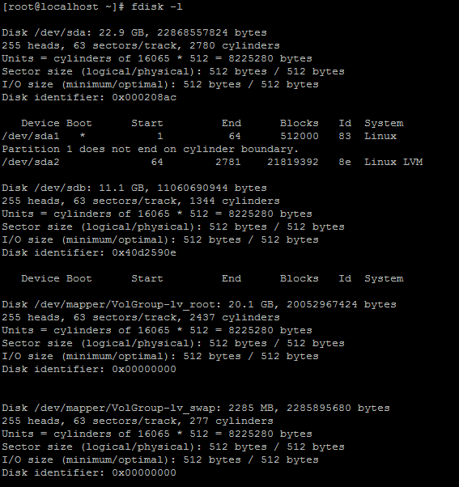

Now going to create the Lvm partion

Create the lvm partiotion with 8e code

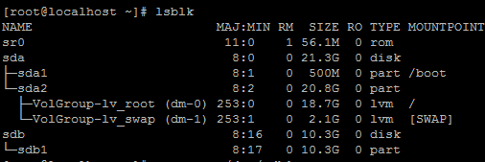

Now I m going to create pv



Vgcreate



Create the LV

lvcreate -L 1GB -n openpath kvit



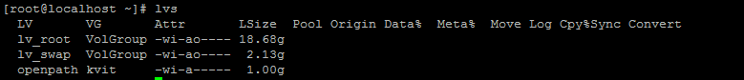

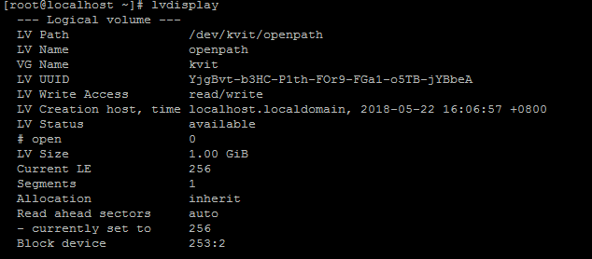

Format the lv partition

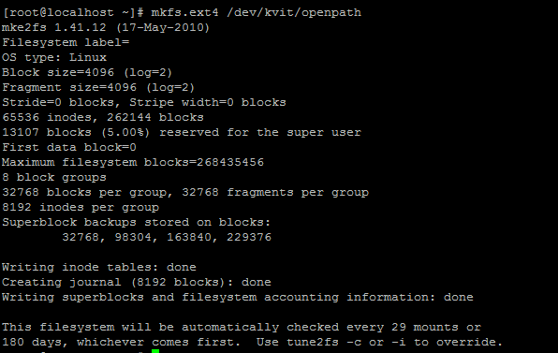

And mount the partition



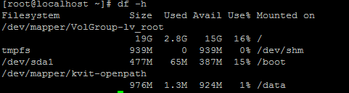

Extent the partition

lvextend -L+500M /dev/kvit/openpath



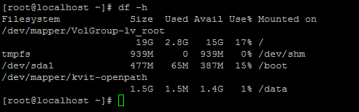

Reducing Logical Volume (LVM):

Let’s wee what are the 5 steps below.

unmount the file system for reducing.

Check the file system after unmount.

Reduce the file system.

Reduce the Logical Volume size than Current size.

Recheck the file system for error.

Remount the file-system back to stage.

umount /dev/mapper/kvit-openpath /data

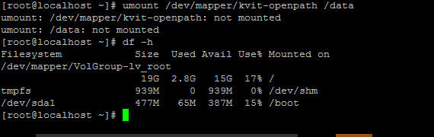

Reduce the LVM now

lvreduce -L -1G /dev/kvit/openpath

